Page 1 of 5

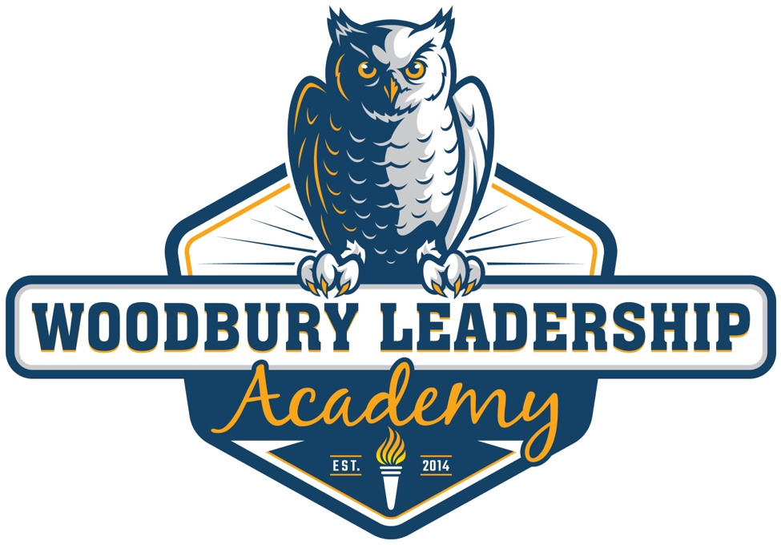

Reading Well by Third Grade
Local Literacy Plan

Page 2 of 5

Overview of Literacy Plan

MN Statute 120B.12 states that a school district must adopt a local literacy plan to have every child reading at or above grade level no later than the end of grade 3. This legislation is commonly referred to as “Reading Well by Third Grade”. The literacy plan “must include a process to assess students’ level of reading proficiency, notify and involve parents, intervene with students who are not reading at or above grade level, and identify and meet staff development needs.”

Belief Statement From MDE

Reading well by third grade is one of many developmental milestones in a child’s educational experience. Literacy development starts at an early age and is the basis for all academic success. Reading well by grade three ensures that a student has a solid foundation of literacy skills to continue to expand their understanding of what they read, make meaning, and transfer that learning across all subject areas. Instruction that provides the basis for all students to read well by third grade and beyond will help close the achievement gap and ensure that all students are ready for the demands of college and the workplace. From cradle to career, a sustained effort to create quality literacy environments in all of our schools and programs from birth through grade 12 promotes academic success. – Minnesota Department of Education

Goals of Literacy Plan

- Ensure all students are receiving the supports needed to meet grade level reading benchmarks.

- Ensure plans are in place to support students in achieving projected growth.

- Communicate clearly with stakeholders the efforts in place to ensure all students are reading well by the end of grade 3.

How will WLA know if our students are reading well by the end of Grade 3?

Reading proficiency will be defined as students who perform at or above grade level on benchmark assessments and in their grade level classroom. Reading proficiency will be ensured for all students kindergarten through 3rd grade through the use of multiple measures assessments, data-driven instruction, and a response to intervention (RTI) approach. Students reading below grade level will receive research-based interventions, in tandem with core knowledge curriculum, until they are able to meet grade level reading benchmarks.

Page 3 of 5

Assessment Plan
Kindergarten through third grade students at Woodbury Leadership Academy participate in the MAP reading fluency assessment 3 times a year. This assessment is a multiple measures assessment, that helps track students’ progress towards reading benchmarks in foundational reading skills and oral reading fluency. This assessment also incorporates a screener for characteristics of dyslexia. It is not a diagnostic assessment for reading difficulties.

The benchmarks for MAP Reading Fluency are tailored to align with the developmental stages of reading. It is our goal to have all students achieve fluent oral reading by the end of grade 3. If students are not meeting fall, winter, or spring expectations, they will receive targeted services through small group instruction. Falling below benchmarks will also put student into consideration for RTI services from one of our RTI specialists.

Grade | Fall | Winter | Spring
K | “No Expectations” Foundational Skills Level 1 | “No Expectations”  Foundational Skills Level 2 | “No Expectations”  Foundational Skills Level 3
1 | “No Expectations” Foundational Skills Level 3 | Foundational Skills Level 4-5 | 200L or greater AND Accuracy is 95–97%  60-90 WCPM
2 | 200L or greater AND accuracy is 95–97%  50–83 WCPM | 300L or greater AND accuracy is 95–97%  84 - 108 WCPM | 400L or greater AND accuracy is 95–97%  100-123 WCPM
3 | 400L or greater AND accuracy is 95%-97%  83–103 WCPM | 500L or greater AND accuracy is 95–97%  97-136 WCPM | 500L or greater AND accuracy is 95–97%  112-138 WCPM
Our primary assessment is MAP reading fluency, but students can also be considered for targeted services if they fall below target scores on other assessments. In addition to MAP reading fluency, Woodbury Leadership Academy will consider in class assessments from the CKLA skills curriculum as an indicator of student progress towards meeting grade level reading benchmarks. Core Knowledge Language Arts Skills curriculum is a science of reading based curriculum that focuses on foundational reading skills, comprehension and oral reading fluency.
Data used to determine whether they receive services includes, but is not limited to the MAP reading fluency MCA (grade 3), CKLA skills benchmarks, fluency benchmarks, and classroom observation data. Students are considered meeting grade level expectations if they maintain at or above grade level benchmarks on assessments. Students who qualify for special education services will receive their targeted interventions through their IEPs.
Page 4 of 5

Communication
Communication between Woodbury Leadership and families will be on going throughout the school year. It starts with our Back to School/Open House and continues throughout the year through two teacher conferences and ongoing phone calls and meetings. Each year parents are provided information that shows the reading growth of their child.
Students reading 1 or more levels below grade level expectations will receive targeted intervention services from our RTI specialists. Parents will receive a formal notification that their student is entering support services and will receive frequent updates from the specialists on their student’s progress. In addition, intervention specialists and teachers will provide the family with resources for support the reading growth of their child.
If a student is reading below grade level after their winter assessments, they will take dyslexia screener. Parents will be notified of their child’s participation in the screener and will receive results of the screener promptly with information on how to interpret results. Follow up on results should be done through an outside entity as our screener can only identify characteristics of reading difficulty, and cannot diagnosis dyslexia.
Finally, families will receive report cards 3 times a year that provide a rating of their child’s proficiency in reading. This report will be mailed to families at the end of each trimester. The envelope will include their report card and any recent assessment results.
Professional Development
Teachers will receive 8 hours of professional development in using the CKLA curriculum, a science of reading based curriculum. Intervention specialists will receive Ltters training and provide staff annually with a minimum of one hour of professional development in teaching reading. In addition, teachers will meet for grade-level/specialty area Professional Learning Community (PLC) meetings for weekly one-hour meetings. Much of this time will be devoted to reviewing data, setting goals, discussing instructional effectiveness, writing common assessments, and reviewing curriculum standards.
Annually, teachers are given professional development regarding indicators of dyslexia, mental health, and other learning/medical disabilities that may impact students learning.

Page 5 of 5

Woodbury Leadership Academy’s Performance
MAP Reading Fluency Scores Spring 2023
Kindergarten | 84%
1st | 52%
2nd | 70%

