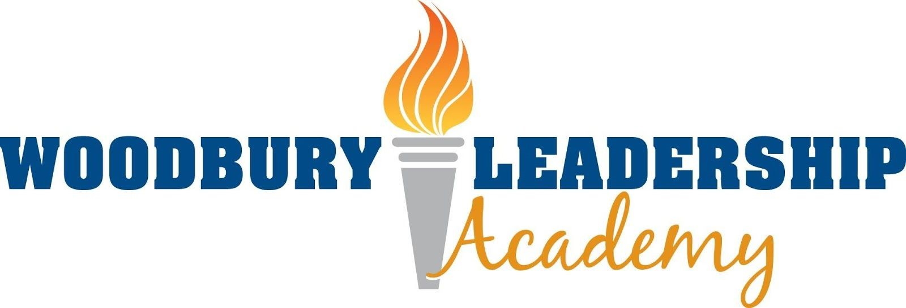
WLA Board of Directors

Declaration that an in-person meeting of the Board is not practical or prudent

Woodbury Leadership Academy (WLA) is a public body and therefore is required to comply with the Open Meeting Law. However, the Minnesota legislature has considered the challenges of such public meetings, and Minnesota Statutes, section 13D.021. Section 13D.021, subdivision 1 permits public bodies to hold meetings via telephone or other electronic means if the conditions of this section are met.
Section 13D.021 requires a public body to make a determination that an in-person meeting is “not practical or prudent because of a health pandemic or an emergency declared under chapter 12.”
ˇThe Board of Directors of Woodbury Leadership Academy declares that due to the fact that Governor Walz has declared an emergency under Ch. 12 because of a health pandemic, an in-person meeting of the Board is not practical or prudent. Meetings will be held via telephone or other electronic means until school resumes.

WLA will meet the following requirements when holding a virtual meeting:
- The notice of a change from an in-person to a virtual meeting will be posted at least three (3) days in advance of the meeting.
- All votes must be conducted by roll call, so each member’s vote on each issue can be identified and recorded.
- We will take steps to allow members of the public who wish to monitor the meeting from a remote location be able to do so.
- The board packet will be made available on the school’s website so that members of the public who choose to monitor the meeting remotely can have access to the packet.

______________________ ____________________________________
Date Mandi Folks, WLA Board Chair

